TESTING:

Software testing is the process of evaluating and verifying that a software product or application does what it is supposed to do. It involves executing software/system components using manual or automated tools to evaluate one or more properties of interest.

The purpose of testing is to identify errors, gaps, or missing requirements in contrast to actual requirements.Testing measures the overall quality of the system in terms of its correctness, completeness, usability, performance, and other functional and non-functional attributes. The benefits of testing include preventing bugs, reducing development costs, and improving performance.

STLC(SOFTWARE TESTING LIFECYCLE):

The procedure of software testing is also known as STLC (Software Testing Life Cycle) which includes phases of the testing process.The testing process is executed in a well-planned and systematic manner. All activities are done to improve the quality of the software product.

DIAGRAM:

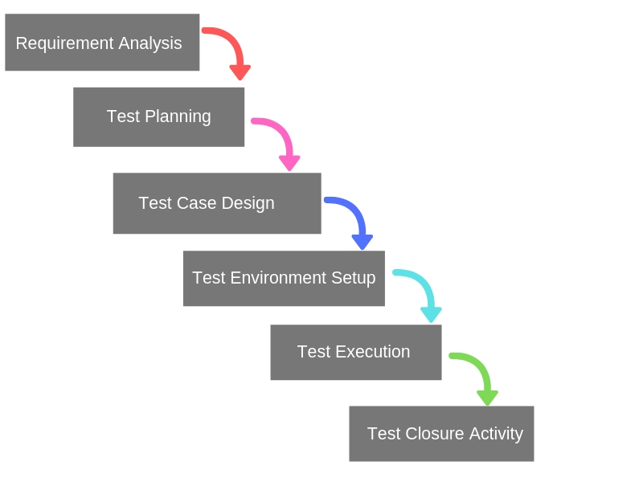

REQUIREMENT ANALYSIS:

The team first double checks the clarity and of the requirement and discusses the agreed requirements. Then they thoroughly study them to get a grip on the scope of the system and mirror it in a Requirement Traceability Matrix.

TEST PLANNING:

The techniques and approaches of the tests are discussed, finalized and documented as a Test Plan in this stage. It is important for all the team members, to brain storm and choose the technique with the smartest test coverage.

TEST CASE DESIGN:

The QA team creates and cross checks clear and comprehensive Test Cases on an atomic level.

TEST ENVIRONMENT SETUP:

Here either QA or the development team fulfills all the hardware and software requirements to deploy a Test Environment and the team tests the major functionalities. One has to be very careful and focused while doing so because this will determine if the software is stable enough for the testing or not. All the actual testing depends on this activity.

TEST EXECUTION:

 The test cases are run according to the given steps and expected results and every test case is marked as pass OR fail and Test Results are created.

TEST CLOSURE ACTIVITY:

Test And Bug Reports are generated and discussed so that the upcoming risks and failures can be handled by using past experiences and knowledge of the current state of the system.